|  |  |
| --- | --- |
| [KAN-19] [Another product is displayed in your favorites](https://tmelnychok30.atlassian.net/browse/KAN-19) Created: 15/вер./24  Updated: 15/вер./24 | |
| **Status:** | To Do |
| **Project:** | [Pet-Project AI Guru](https://tmelnychok30.atlassian.net/secure/BrowseProject.jspa?id=10000) |
| **Components:** | None |
| **Affects versions:** | None |
| **Fix versions:** | None |

|  |  |  |  |
| --- | --- | --- | --- |
| **Type:** | Bug | **Priority:** | Medium |
| **Reporter:** | [Tetiana Melnychok](https://tmelnychok30.atlassian.net/secure/ViewProfile.jspa?accountId=712020%3A4e68e605-a434-4948-bfa8-bb53c39de0a3) | **Assignee:** | [Tetiana Melnychok](https://tmelnychok30.atlassian.net/secure/ViewProfile.jspa?accountId=712020%3A4e68e605-a434-4948-bfa8-bb53c39de0a3) |
| **Resolution:** | Unresolved | **Votes:** | 0 |
| **Labels:** | UI, functional | | |
| **Remaining Estimate:** | Not Specified | | |
| **Time Spent:** | Not Specified | | |
| **Original estimate:** | Not Specified | | |

|  |  |
| --- | --- |
| **Attachments:** | Screenshot_98.png |
| **Issue links:** | |  |  |  |  | | --- | --- | --- | --- | | **Blocks** | | | | | blocks | [~~KAN-11~~](https://tmelnychok30.atlassian.net/browse/KAN-11) | Testing the function of adding a prod... | Done | |
| **Rank:** | 0|i0003r: |

|  |  |
| --- | --- |
| **Description** |  |

|  |
| --- |
| Steps: 1. Follow the link: <https://aiguru.com.ua>; 2. Click on the main menu item "Корисні матеріали"; 3. Move the cursor over the heart icon of the "AI List Помічник коду" product; 4. Click on the heart icon; 5. Scroll up the product page and click on the heart icon in the upper right corner.  Expected result: The icon is active; redirection to the page of selected products; the selected product is displayed on the page of selected products.  Actual result: Another product is displayed on the selected products page. |

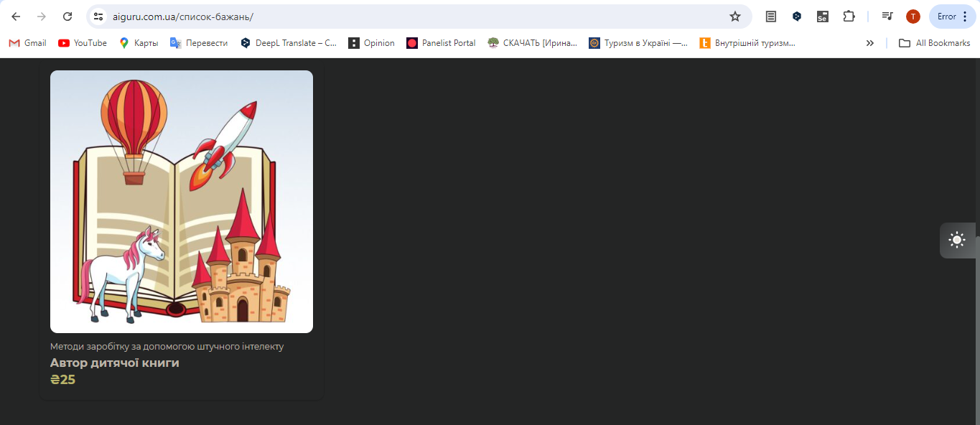

Generated at Wed Sep 18 10:10:11 UTC 2024 by Tetiana Melnychok using Jira 1001.0.0-SNAPSHOT#100266-rev:ad659bfedd37e84df77f3282f1ff9608fe72e5e4.